**Notice of Non-Consent to Vaccination/PCR Testing/Mask Wearing/QR-Scanning for a minor.**

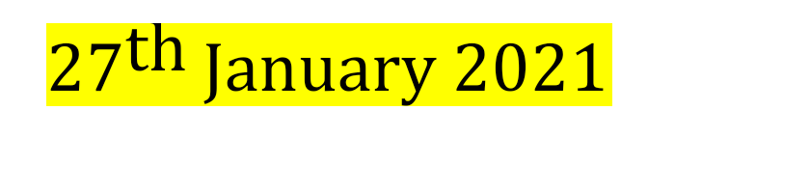

**Office Found**

(Insert principle/s name/s)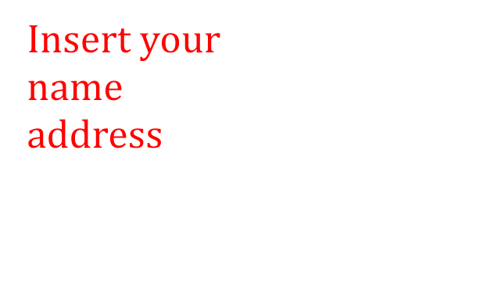

school

address

Notice to the Agent is Notice to the Principal

Notice to the Principal is Notice to the Agent

This is the Self-Executing-Contract

Lawful-binding-contract

This is not private and confidential :covert:

This is public and transparent :overt:

UCc §. 1-308

All rights reserved unequivocally

Statute act offences are the colour of law and are not the rule of law and the rule of law is very simple: do no harm, loss damage or injury to other men and woman as that is the international criminal offence and is war crimes pursuant to the United National charter;

Self-executing contract registration number: RPP44.....(insert registered mail envelope number)

Post mark registration date: / /2020 (insert posting date)

SILENCE-IS-ACQUIESCENCE:

AGREEMENT-AND-DISHONOUR-IS-BY  
 THIS-SELF-EXECUTING-CONTRACT-TACIT-AGREEMENT

***Ignorantia juris non excusat – ignorance of the law excuses not***

Ex nudo pacto non oritur action. No action arises on a naked contract without a consideration. See Nudum Pactum.

Notice to Bailee/s: The Agent to Principal/Principal to Agent; and any and all assigns, nominees, heirs and successors by the sole trader/bailor: (Insert parents name) John-Henry: Smith

To (Insert principle/s name/s),

I here now notify you (Insert principal/s name/s) in your commercial, personal and private capacities also known as “Principal” of “(insert school name in full as the company including Pty Ltd if a private school)” Trading under ABN (look it up and insert)., in its entirety, located at (insert full address of school), Australia, that I do not consent to the living man (Insert student name), born on the (Insert date of birth of student), to receive any form/substance/method of administration, into the living man, of agents marketed as “vaccines”, while under the supervision/duty of care of this school in its entirety. This includes, but is not limited to any agent worded as “vaccination”/ “inoculation”/ “immunisation” or biomedical synthetic agent advertised to target any known or patented coronavirus, especially “Severe Acute Respiratory Syndrome”,“SARS-CoV-2/COVID-19” and its variants/mutations.

I am also advising that I do not consent under any circumstances to the living man (Insert student name), being subjected to any form of testing/investigation/procedure/collection aimed at obtaining DNA/RNA from the living man or from any “virus”, “bacteria”, “parasite”, “fungi” or “disease”, or other condition related to the current political campaign marketed as “A Pandemic”. This includes, but is not limited to the “testing” currently marketed as targeting “SARS-CoV-2” or “COVID-19”, or any variant/mutation of such, and being performed under the guise/description/ “test” known as “Real-Time Polymerase Chain Reaction” or “Reverse-Transcription Polymerase Chain Reaction”, more commonly written/abbreviated as “RT-PCR”.

(Insert student name) will not be participating in the “QR-scanning” “mandate”/collection of personal details/personal information gathering scheme under the guise of “contact tracing”, initiated by the NSW GOVERNMENT (**if not in NSW and insert government departments relevant to state)** trading under ABN *******, nor will he be providing personal details intended to be provided/passed-on/supplied to **(Delete next bit if not in NSW and insert government departments relevant to state)** “NSW GOVERNMENT” (trading under ABN *******), or “THE COMMONWEALTH OF AUSTRALIA” (trading under ABN 98724451651), or SERVICE NSW (trading under ABN 37 552 837 401) or NSW POLICE trading under (ABN 43 408 613 180), or NSW HEALTH (trading under ABN 92 697 899), or any QUEENSLAND STATE GOVERNMENT (This last is included if you are close to a border and activities may take them across. If not relevant then delete), department designed to fulfil those same functions. The act of collecting private details without the consent of the individual and passing them to a third party is not lawful under *Section 94H of the Privacy Act 1988*. In the year 2020, SERVICE NSW was the target of one of the largest privacy data breaches ever to affect a NSW Government Agency, and was found by the Auditor-General of NSW to “continue to pose a risk to the safety and security of personal information”. Identity theft is real and creates a significant harm to the affected living wo/man.

(Insert student name) has a medical exemption from wearing a mask or any other face covering that reduces in any way the natural exchange/free flow of gas to and from the airways and lungs, or is designed to prevent/inhibit free and fluid speech and mask/hide facial expression, and is designed/explicitly used/intended to prevent/protect the spread of the virus marketed as “COVID-19/SARSCoV-2”. Please be aware that discrimination against an individual with a medical condition is unlawful under *The Discrimination Act of 1988.*

I here now notify you, that should (Insert student name) be excluded from any school based activities or subjected to any of the above-mentioned unlawful “mandates”, then it will be deemed a privacy breach and/or assault, and/or discrimination which will result in legal action being commenced against the individuals known as (Insert principle name.) Should a representative of (Delete if not in NSW and insert government departments relevant to state) SERVICE NSW ABN 37 552 837 401, or any agent representing an “Australian Government Department” attempt to conduct any “testing” or “vaccination” on students of your school, I am to be immediately informed. Under your duty of care (Insert student/s name) is to be removed to an area of safety until I, (Insert mother/father’s name) arrive to relieve you of that duty of care and escort him/her safely from the school premises.

As “Principle” you have accepted full responsibility for the students at Insert School., and have a legal/lawful duty of care. Part of that duty requires a working knowledge of the difference between lawful and legal, and the use by private companies such as SERVICE NSW trading under ABN 37 552 837 401(make sure the department is relevant to your state), of words such as “mandates” and “directives” who will at times attempt to coerce/trick/fool you into forming contracts with them, under the guise of “safety/health/protection”. Maxim in law*– ignorance of the law excuses not.*

# .

A maxim in law *Qui tacet consentit* recognises that silence is acquiescence. If I have not received a response from the “Insert School.”, or a representative agent within 14 days of receipt I will consider you have accepted my notice and terms.

By:

Your name here

Non-negotiable autograph

All Rights Reserved Without Prejudice

UCC1-308(old UCC1-207)

Errors and Omissions Excepted

WITHOUT RECOURSE– NON ASSUMPSIT